Case Presentation: Necrotic Pulp with Acute Apical Periodontitis

Chief Complaint
“Severe tooth pain when biting.”

Differential Diagnosis
- Necrotic pulp with acute apical periodontitis
- Irreversible pulpitis
- Periapical abscess
- Temporomandibular joint pain
Actual diagnosis: Necrotic pulp with acute apical periodontitis
Opening statement: “My tooth hurts really badly when I bite.”

History of Present Illness
You are a 38￼year￼old patient who presents to the emergency department with 5 days of worsening left lower tooth pain. The tooth used to hurt a lot a week ago, then it stopped, but now it's hurting again. You think it might have an old filling that broke. You originally got the filling about 20 years ago, and it hasn’t caused you any problems until recently.
Over the past 48 hours, the pain has intensified and is now sharp with biting , making it difficult to chew on that side.
On a scale of 0-10 (with 10 being worse) your pain is 7 at its worst.
The pain is constant, you have tried Advil/Motrin (ibuprofen) but the pain is still there.
You do not have facial swelling, purulent drainage, fever, chills, difficulty swallowing, drooling, or shortness of breath.
The last time you saw a dentist was 5 years ago. You haven't been able to see a dentist because you no longer have dental insurance.

Past Medical History
General health is excellent; you are healthy and have no medical problems.

Medications
- Motrin or Advil 400 mg as needed
- You do not have a history of using opioids or any issues with opioid use or abuse
- You do not have any contraindications for using ibuprofen (Motrin or Advil)

Allergies
- You are allergic to penicillin
- If the provider asks you what happens when you take penicillin, you say “I get hives”

Social History
- Tobacco: 1 pack per day
- Alcohol: Occasional
- No illicit drug use
- Presentation/emotional tone:
You will be sitting in a chair, in your normal clothes. You are tired, uncomfortable, and holding the left lower side of your face because of the pain. Your face is normal and not swollen. You can open your mouth normally. Your voice is normal.

Physical Examination
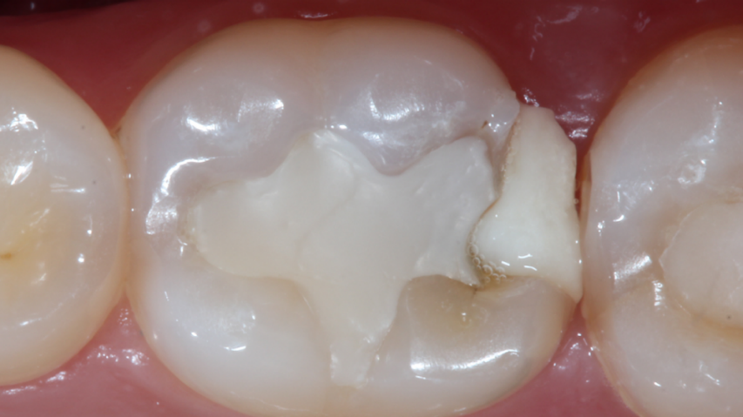

Oral Cavity
- You have a large filling on the lower left molar
- When you drink something cold right now, it is not painful. It used to be painful a while ago
- You have sharp pain or tenderness when biting or chewing. If the provider taps your this tooth it really hurts, it is tender
- No gingival “gum” swelling, fluctuance, or purulence. There is no abscess in your mouth.
- There is some tenderness when the provider presses or palpates your gums next to this tooth

Emergency Department Management

The provider should offer you a dental block, also called “nerve block” or dental anesthesia, that numbs the teeth and surrounding tissues for a few hours. You can deny the block. The provider should offer you the following

Pain Control
- NSAIDs (ibuprofen) Advil/ Motrin 400 -600 mg every 4-6 hours ± acetaminophen (Tylenol) up to 1000 mg (2 extra strength every 4 hours)
- Short course of opioid analgesics if the patient has tried the above regimen without adequate relief

- Antibiotics are not needed for your case; however, the provider should provide an antibiotic prescription and tell you that you only need to take the antibiotic if you start developing fevers, swelling, or you see pus in your gum (abscess on the gums)

Patient Education
The provider should tell you the following
- Pain will not improve without dental intervention
- You need to see a dentist within 72 hours to receive dental treatment
  - The provider should ask you if you can see a dentist. You should say it will take a while for you to figure that out
- The provider should let you know to watch out for worsening of symptoms like
  - Facial swelling
  - Fever
  - Difficulty swallowing or breathing

Referral
The provider should ask you if you would like to save your tooth. You want to save your tooth.

Checklist:
- What was your experience like during this encounter with the provider using the clinical decision support tool for dental pain? Good/neutral/bad
  - Please explain (open-ended)
  - Did you feel worried that the provider was using a CDST? Why or why not? (open ended)
Answer Yes/No for the following questions
- Did the provider ask if you have a fever?

- Did the provider ask if you are allergic to penicillin?
- Did the provider ask if there is pain with cold?
- Did the provider ask if the pain goes away immediately or persists after removing the cold trigger?
- Did the provider ask if there is pain with biting/chewing/tapping the tooth?
- Did the provider ask you if you have taken Advil/Motrin (ibuprofen) or Tylenol at home?
- Did the provider offer you dental block, dental anesthesia, injection?
  - If yes, did they explain that it provides temporary pain relief
- Did the provider explain why you don’t need an antibiotic?
- Did the provider explain when you would need to take an antibiotic?
- Did the provider tell you that you need to see a dentist soon?
- Did they ask if you are able to see a dentist soon?
- Did the provider ask if you want to save your tooth?

